RELAY NORTH DAKOTA
(Telecommunications Relay Service)
MAKES ALL THE RIGHT CONNECTIONS
RELAY NORTH DAKOTA -- a free service that provides full telephone accessibility to people who are deaf, hard-of-hearing, deaf-blind, and speech-disabled. The relay is open 24-hours a day, 7 days a week, and it is free within your local calling area. Long distance calls made through Relay North Dakota's Provider are billed at a reduced rate due to the additional time needed to place a relay call. http://www.relaynorthdakota.com/
If you are unable to hear or speak, use the relay service which creates a link between an individual using a text telephone device (TTY) which looks like a typewriter or small computer, and a non-TTY user. Operators called Communications Assistants act as go-betweens, relay conversations between a TTY user and a telephone user by speaking everything typed by the ITY user and typing everything said by the telephone user.
To place a RELAY call (TTY), please dial 1-800-366-6888.
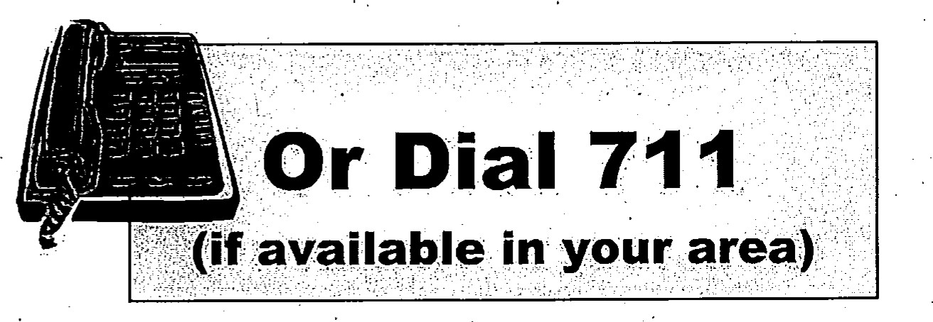
To place a RELAY call (voice users), please dial 1-800-366-6889.

If you are speech-disabled, take advantage of Relay North Dakota’s user-friendly Speech-to-Speech service. Specially trained Relay Operators serve as the speech-disabled user’s voice and repeat their voiced response back to the called party.
For Speech to Speech, please dial 1-877-366-3709 (toll free) or 711.

